
A10
Sreenidhi Institute of Science and Technology
(An Autonomous Institution)
Code No: 101MA06/111MA06
B. TECH. II-Year I-Semester Examinations, December 2015 (Supplementary)
MATHEMATICAL METHODS (ME)

Time: 3 Hours Max. Marks: 70

Note: No additional answer sheets will be provided.

Part - A
Max.Marks:20

Answer all QUESTIONS. EACH QUESTION CARRIES 2 MARKS.

1. Find a real root of the equation x=e^{-x} using Newton Raphson method.

2. For x=0,1,2,3,4: f(x)=1,14,15,5 respectively. Find f(3) using forward difference table.
3. Using Runga - Kutta method, find y(0.2) for the equation 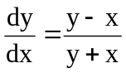, y(0)=1, Take h=0.2.
4. Form the partial differential equation by eliminating the arbitrary function from z=xy+f(x²+y²).
5. Define Fourier Cosine transform.
6. Write 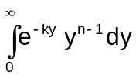in terms of Gamma function.
7. Find 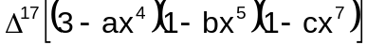.
8. Write the formula to evaluate approximate value of 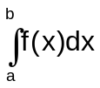 using Simpsons 3/8th rule.
9. Find the general solution of 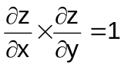.
10. Express 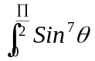 Cos⁹ θdθ in terms of Beta function.
Part – B
Max.Marks:50

ANSWER ANY FIVE QUESTIONS. EACH QUESTION CARRIES 10 MARKS.

1. Find the Newton's forward difference interpolation a polynomial for the data
x | 0 | 1 | 2 | 3 | 4
f(x) | 1 | 3 | 7 | 13 | 25
2. a) Find the missing term from the following data
x | 0 | 1 | 2 | 3 | 4
y | 1 | 3 | 9 | -- | 81
b) Certain experimental values of x and y are given below
x | 0 | 2 | 5 | 7
y | -1 | 5 | 12 | 20
If y=mx+c, find approximate values of m and c.

3. a) Use Runge - Kutta Method to find y(0.1) for the equation
y'=xy+y²; y(0)=1
b) Evaluate 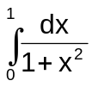using Simpson's 3/8th rule.
4. a) Evaluate 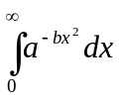.

b) Evaluate 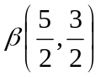.

5. Find the Fourier sine transform of e^{-|x|}. Hence show that 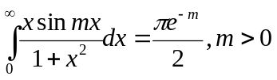.

6. a) Express in terms of Legendre polynomials.

b) Prove that 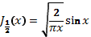.
7. a) Find Newtons divided difference interpolation polynomial for the
following data
 | 1 | 2 | 4 | 8 | 10
 | 0 | 1 | 5 | 21 | 27

b) Using Taylor’s series method, solve the equation, for given that

8. a) Form the partial differential equation by eliminating the arbitrary function)

b) Find the Fourier transform of
if
0, if

-- 00 -- 00 --

